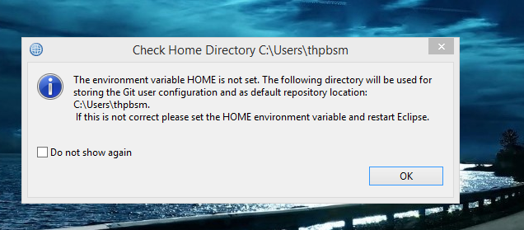

C:\Users\thpbsm\IBM\IIBT10\workspace

https://www.kelltontech.com/kellton-tech-blog/github-plug-configuration-and-usage-iib

C:\Users\thpbsm\git

NGITestRepository

https://github.com/eclipse

http://www.eclipse.org/egit/download/

http://wiki.eclipse.org/EGit/FAQ#Where_can_I_find_older_releases_of_EGit.3F - working with 2.6 version

http://git.iga.gov.bh/users/sign_in - thpbsm , password1234

http://git.iga.gov.bh/NGI/NGI_Broker_PPBPELFlows.git

http://download.eclipse.org/egit/updates-2.1